XPath Injection
# Source: AI Source: Provided by: [Data Path: Persons Table -> ID Column: 1, Name_En Column: Motasem Essam] -> From: [ChatGPT] on [1/18/2026]
XPath Injection is a type of security vulnerability where an attacker injects malicious input into an XPath query used to retrieve data from XML documents. This can allow the attacker to manipulate or bypass XML-based authentication or access unauthorized data.

How XPath Injection Works
# Source: AI Source: Provided by: [Data Path: Persons Table -> ID Column: 1, Name_En Column: Motasem Essam] -> From: [ChatGPT] on [1/18/2026]
Applications use XPath queries to search or authenticate users based on XML data. If user input is directly embedded into these queries without validation or escaping, attackers can inject crafted XPath expressions that alter the query’s logic.

Example
# Source: AI Source: Provided by: [Data Path: Persons Table -> ID Column: 1, Name_En Column: Motasem Essam] -> From: [ChatGPT] on [1/18/2026]
Suppose an application runs this XPath query to check login credentials:
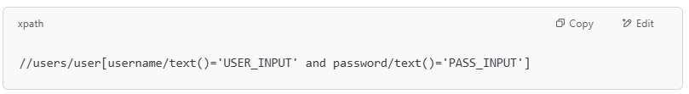
//users/user[username/text()='USER_INPUT' and password/text()='PASS_INPUT']

If the attacker enters this as USER_INPUT:
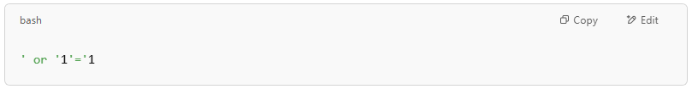
' or '1'='1

The query becomes:
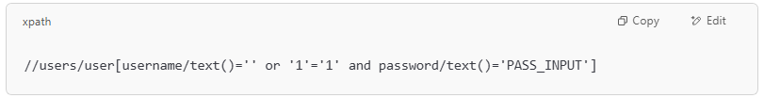
//users/user[username/text()='' or '1'='1' and password/text()='PASS_INPUT']

Since '1'='1' is always true, this returns all users, potentially bypassing authentication.

Risks of XPath Injection
# Source: AI Source: Provided by: [Data Path: Persons Table -> ID Column: 1, Name_En Column: Motasem Essam] -> From: [ChatGPT] on [1/18/2026]
- Authentication bypass
- Unauthorized data access
- Data manipulation (depending on XML processing)
- Information disclosure

How to Prevent XPath Injection
# Source: AI Source: Provided by: [Data Path: Persons Table -> ID Column: 1, Name_En Column: Motasem Essam] -> From: [ChatGPT] on [1/18/2026]
- Validate and sanitize all user inputs
- Use parameterized XPath queries or safe XPath libraries
- Escape special characters (', ", &, <, >, etc.) in input
- Apply least privilege to XML data access
- Use XML schema validation to enforce expected input formats

